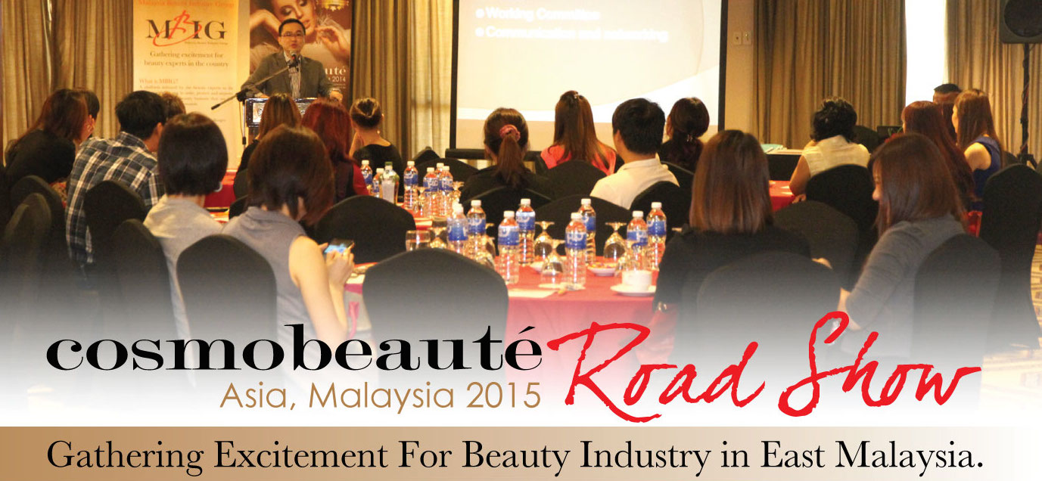

REGISTRATION FORM

FULL NAME: …………………………………………………………………

COMPANY NAME: …………………………………………………………..

MOBILE NUMBER: ………………………………………………………….

EMAIL ADDRESS: …………………………………………………………..

NATURE OF BUSINESS: …………………………………………………..
(EG: BEAUTY SALON / NAIL SALON / HAIR SALON / SPA / ACADEMY)

AREA OF INTEREST: ………………………………………………………
(EG: SKIN CARE / AESTHETICS / COSMETICS / NAIL&HAIR CARE/ SPA)

RSVP FOR ROAD SHOW:
[ ] 5TH MAY 2015 @ FOUR POINTS BY SHERATON, KUCHING

[ ] 7TH MAY 2015 @ 1 BORNEO HOTEL, KOTA KINABALU

Please complete this form and email to samanthawong@ecmi.com.my.

For more information, please contact Ms. Samantha Wong at samanthawong@ecmi.com.my or call +603 8023 0820.

****************************************************************************************

CONGRATULATIONS!
YOU HAVE SECURED YOUR SEAT!

